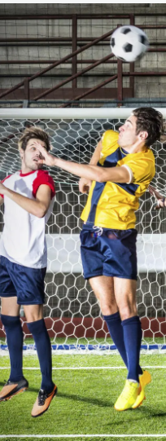
HEADBALL PASS IMAGE

